5. BFS

Aim:
To implement the Breadth-First Search (BFS) algorithm using Python to traverse a graph level by level.

Objective :
- To understand the Breadth-First Search (BFS) algorithm.
- To traverse all the vertices of a graph using a queue.
- To visit each node exactly once.
- To display the BFS traversal order.

Algorithm:
- Start.
- Create a graph using an adjacency list.
- Create an empty visited list and an empty queue.
- Choose the starting node.
- Mark the starting node as visited and add it to the queue.
- Repeat until the queue becomes empty:
- Remove the first node from the queue.
- Display the node.
- Visit all its unvisited adjacent nodes.
- Mark each adjacent node as visited and add it to the queue.
- Stop.

Flowchart :
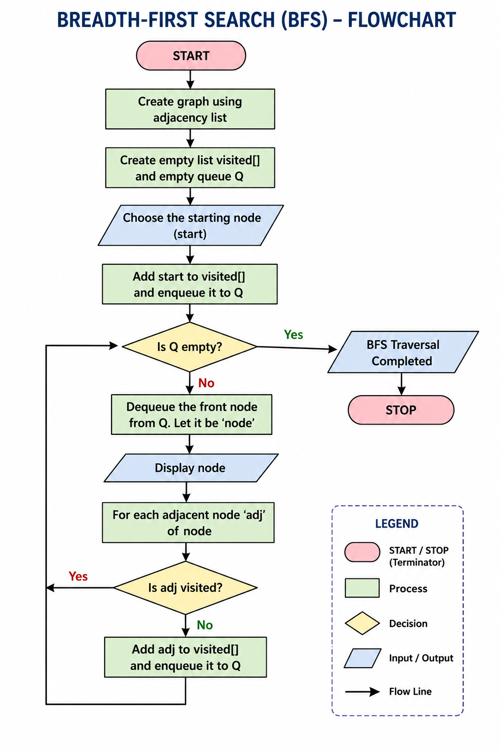

Code:
graph = {
'A': ['B', 'C'],
'B': ['D', 'E'],
'C': ['F'],
'D': [],
'E': ['F'],
'F': []
}
visited = []
queue = []
start = 'A'
visited.append(start)
queue.append(start)
print("BFS Traversal:")
while queue:
node = queue.pop(0)
print(node, end=" ")
for neighbour in graph[node]:
if neighbour not in visited:
visited.append(neighbour)
queue.append(neighbour)

Output:
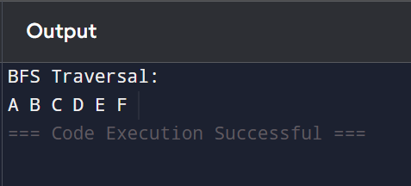
Result :
The Breadth-First Search (BFS) algorithm was successfully implemented using Python. The graph was traversed level by level starting from the source node, and the traversal order is obtained.

